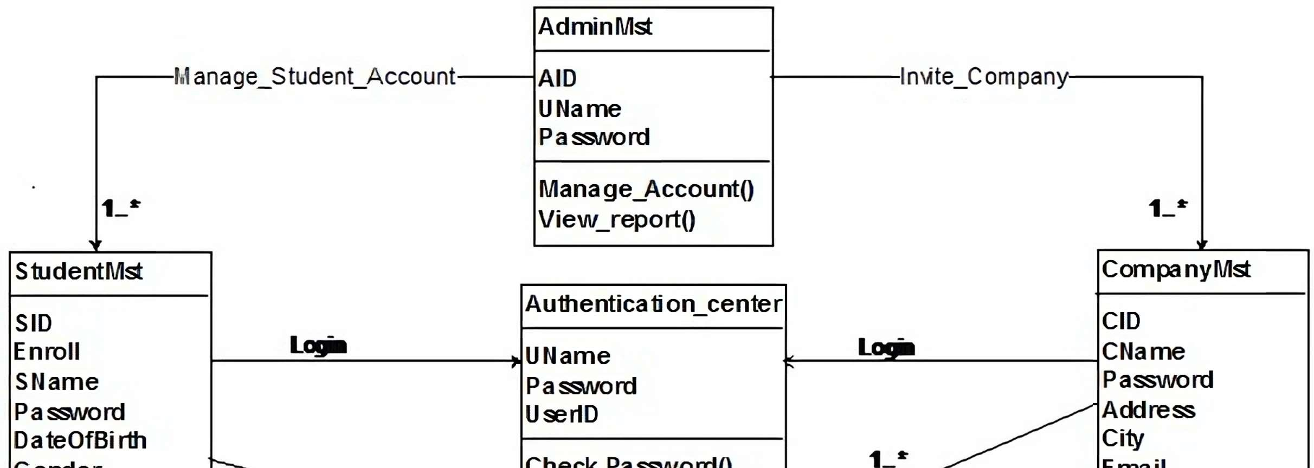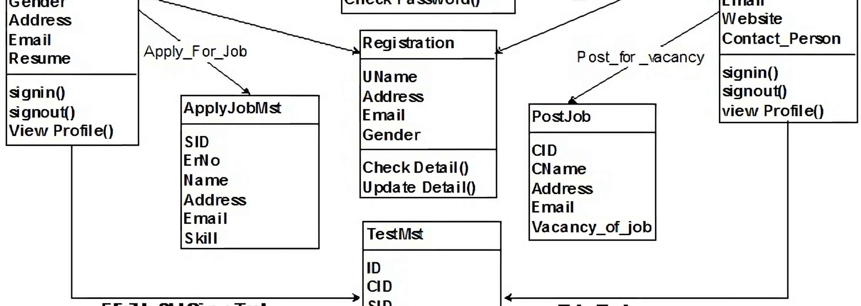

Eligible

to

give

test

Take test

login

login

SE EXP 8

Niikunj Makharria 21CE1246 D1